

TRIBHUVAN UNIVERSITY
FACULTY OF HUMANITIES AND SOCIAL SCIENCES
A Project Report
On
“MovieMagic – “The Streaming Aspect for Cinematography”

Submitted to:
Department of Computer Application
National College of Computer Studies

In partial fulfillment of the requirements for the Bachelor’s Degree in Computer
Application

Submitted By:
Rusha Manandhar
TU Regno: 6-2-551-178-2021
Date: 6th Baisakh, 2082

ABSTRACT

MovieMagic is a cheap quality online movie streaming service MovieMagic which makes premium entertainment accessible to a wider audience. The project uses a waterfall methodology, which means that it runs through a series of steps in a structured approach — planning and then moving through design, implementation, and then testing steps. Front-end employs HTML, CSS, JavaScript and back-end used is PHP with MySQL to provide the fast and secure user experience. Support — The platform incorporates secure user authentication, a continually updated library of movies and shows, personalized recommendations, and user reviews. It also serves the users with trending content on the basis of locality. MovieMagic has been tailored to different user preferences with an insight on performance, usability, and accessibility.

Table of Contents

ABSTRACT i
LIST OF ABBREVIATIONS iii
LIST OF FIGURES iv
LIST OF TABLES v
Chapter 1: Introduction 1
1.1 Introduction 1
1.2 Problem Statement 1
1.3 Objective 2
1.4 Scope and Limitation 2
1.5 Report Organization 2
Chapter 2: Background Study and Literature Review 4
2.1 Background Study 4
2.2 Literature Review 4
Chapter 3: Requirement Analysis and Feasibility Study 6
3.1 System Analysis 6
3.1.1 Requirement Analysis 6
3.1.2 Feasibility Study 7
3.1.4 Process Modeling 10
3.1.5 Flow Chart for Admin: 13
3.1.5 Flow Chart for User: 14
Chapter 4: System Design 15
4.1 Design 15
4.1.1 Architectural Design 15
4.1.2 Interface design 17
4.1.5 Database design schema 19
Chapter 5: Implementation and Testing 23
5.1 Implementation 23
5.1.1 Tools Used 23
5.1.2 Implementation details of modules 24
5.2 Testing 31
Chapter 6: Conclusion and Future Improvements 34
6.1 Lesson learnt/outcome 34
6.2 Conclusion 34
6.3 Future Recommendations 34
References 36

LIST OF ABBREVIATIONS

Apache | Server
CSS | Cascading Style Sheet
HTML | Hypertext Markup Language
MySql | Database Management System
PHP | PHP Hypertext Preprocessor
SQL | Structured Query Language

LIST OF FIGURES
Figure 1: Waterfall Model 6
Figure 2: Use case diagram of MovieMagic 7
Figure 4: DFD level-0 of MovieMagic 10
Figure 5: DFD level 1 of MovieMagic 11
Figure 6: Flow-chart of Admin 13
Figure 7: Flowchart of User 14
Figure 8: Architectural Design of MovieMagic 15
Figure 9:Interface Design 17

LIST OF TABLES
Table 1 :about 19
Table 2 :genre_info 19
Table 3 :message 19
Table 4 :moviedetails 19
Table 5 :register 20
Table 6 :reviews 20
Table 7 :service 20
Table 8 :watchlist 20

Chapter 1: Introduction

1.1 Introduction
MovieMagic: Web-based movie streaming platform Users can stream a large number of movies and television segments directly from the website without requiring cable or satellite service. However, the screen users are greeted with is fairly simple, with clearly defined categories based on genre and other factors, along with a trailer and description of the content before watching it.
It includes intelligent features that allow for personalized recommendations depending on criteria like user preferences and locality based trending content, user review and rating options, and such other features to keep users engaged on the platform. Intuitive and on-demand, MovieMagic provides users with the ability to stream quality video from anywhere at the touch of a fingertip using web browsers on internet-connected devices. The project caters to a wide variety of tastes by providing a well-rounded and modern streaming experience focused around simplicity, finding new relevant content, and allowing for user input.

1.2 Problem Statement
Expensive, ad-ridden, and poorly personalized, existing movie streaming platforms are exaggerated in payment and poorly tailored content discovery. And most platforms don't have locality based trending content or have enough context information set up like description and trailers. Low user engagement and satisfaction due to lack of features, such as user reviews and reliable recommendations. Until now, however, this model has not catered to all those who want to watch movies without seeking entertainment at any cost. MovieMagic wasn't built for those who want to go far and beyond for a good viewing experience; it was created for people like me who want casual, ad-free entertaining solutions without breaking the bank. If this is your scene, then keep reading as we identify the issues MovieMagic sets out to address—allowing you to watch films or shows without quotations driven from the worth of $$$$ brewing behind the set. Region-based and trending content—no more releasing your desired movie a few months behind due to territorial business habits; in-depth information for each title; an opportunity to receive personalized recommendations.

1.3 Objective

The main objective of this project is:
- To develop a web-based movie streaming platform that offers personalized recommendations and highlights locality-based trending content to enhance content discovery and user engagement.

1.4 Scope and Limitation
MovieMagic is a web-based streaming platform accessible via desktop and laptop browsers. It offers a categorized library of movies and TV shows, complete with trailers, descriptions, and genre filters. Key features include personalized recommendations based on user activity, locality-based trending content, and a review and rating system to encourage user interaction. The platform ensures secure login and smooth streaming, built using HTML, CSS, JavaScript, PHP, and MySQL.
The platform is limited to web access and does not support mobile apps or offline viewing. Features like live streaming, download options, or paid subscription models are not included. The recommendation engine is basic, without AI or machine learning integration. Content availability is limited due to the absence of official licensing or third-party streaming partnerships.

1.5 Report Organization

Chapter 1: It includes the introduction section, the problem we attempted to solve, and the objectives and scope.

Chapter 2: It includes the background study of fundamental theories, general concepts and literature review of similar projects, theories and results by other researchers.

Chapter 3: It provides an overview of all the requirements along with system analysis and feasibility analysis of the system.

Chapter 4: It includes a detailed description of how the system was designed.

Chapter 5: It includes the tools we used to build the system and how the testing process was done.

Chapter 6: It includes the conclusion of the project and how we are further planning to make the system work sustainably.

Chapter 2: Background Study and Literature Review

2.1 Background Study

An analysis of popular streaming services like Netflix, FMovies, and OneTouch Movies was done in order to create a successful and entertaining platform. Although these platforms have a lot of features and content, they frequently have drawbacks like expensive subscription fees, intrusive advertisements, or a lack of tailored content discovery in free alternatives. Seeing these gaps influenced MovieMagic's development to prioritize personalization, accessibility, and a simple, uncluttered viewing experience.

For content integration, the platform uses open-source APIs, with a primary focus on YTS (https://yts.mx/), which provides access to a broad library of movies along with useful metadata like descriptions, genres, and trailers. Additional open-source sources such as TMDB (The Movie Database) and OMDb API (Open Movie Database) are also considered to enrich the platform with comprehensive content details, including cast, ratings, and visuals. These sources collectively support the core features of the platform, such as recommendations, content descriptions, and search functionality, while keeping the platform lightweight and efficient.

2.2 Literature Review

The evolution of video streaming platforms has significantly transformed media consumption patterns over the past decade. Studies and articles related to platforms like Netflix highlight the importance of user personalization, with machine learning algorithms playing a crucial role in recommending content based on watch history and preferences. However, such systems often require complex infrastructure and large datasets, making them less feasible for smaller or independent platforms.

Research into free streaming sites like FMovies and OneTouch Movies reveals a focus on wide content availability but also points out drawbacks such as lack of user engagement features, poor content categorization, and intrusive advertising. These issues affect user retention and overall satisfaction. In contrast, academic papers on streaming UX emphasize that clean design, localized content suggestions, and minimal friction during navigation significantly improve viewer engagement.

Open-source APIs such as YTS, TMDB, and OMDb have also been explored in existing literature for their usefulness in educational or experimental projects. These sources provide structured data on films, including metadata, trailers, posters, and more, enabling developers to implement dynamic content integration without hosting large media files.

From this review, it is evident that a successful streaming platform must balance accessibility, personalization, and clean UI. Drawing from the strengths and limitations of existing platforms and literature, MovieMagic aims to deliver a lightweight, informative, and user-driven streaming experience focused on core features like recommendations, locality-based trends, and user feedback systems.

Chapter 3: Requirement Analysis and Feasibility Study

3.1 System Analysis

Requirement Analysis

System Design

Implementation and
Unit Testing

Integration and
System Testing

Figure 1: Waterfall Model
The development of MovieMagic follows the Waterfall Model, a linear and sequential approach that ensures each phase is completed before moving to the next. This model is ideal for projects with well-defined requirements and allows for thorough planning, design, and implementation with minimal risk of major changes during development.

3.1.1 Requirement Analysis

The goal of the requirement analysis process for this project was to determine the essential functions and features of the system as well as any restrictions or limits that would need to be taken into account when it was being developed.

3.1.1.1 Functional Requirement
The movie streaming platform must include a robust content collection with search and filtering features, safe user authentication, and efficient video playback management. The system can only be accessed by the admin. Movies and information can be added, removed, or edited by the admin. Movies may be streamed and browsed online. Additionally, users may choose which movies to watch from a variety of genres and categories.

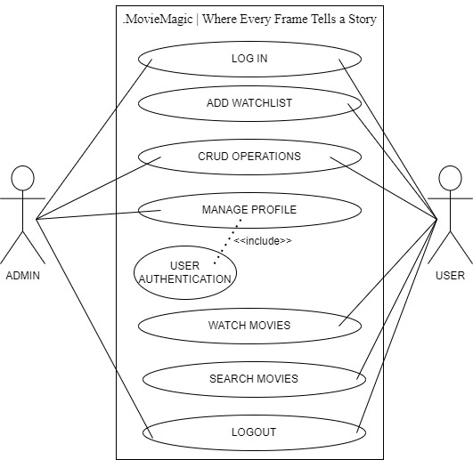
Figure 2: Use case diagram of MovieMagic

3.1.1.2 Non-functional Requirement
The non-functional requirements for the movie streaming platform focus on ensuring reliability, performance, and security. The platform should provide high availability and fault tolerance to minimize downtime and ensure continuous access to content. Performance metrics include fast load times and seamless video playback with minimal buffering, supported by a scalable infrastructure to handle varying levels of user traffic and large volumes of video data. The system must also be maintainable and extendable, allowing for future upgrades and the integration of new features without significant disruption.

3.1.2 Feasibility Study
The feasibility study assesses the system's functionality under specific constraints, evaluating how viable it is to develop the system under these conditions. The key feasibility aspects considered include operational, economic, and technical feasibility.

3.1.2.1 Technical Feasibility
The system demonstrates strong technical feasibility by leveraging well-established technologies such as HTML, CSS, JavaScript, PHP, and MySQL. These technologies are widely supported and have extensive documentation, making them reliable choices for building robust web applications. Additionally, the system's hardware requirements are modest, requiring only standard computing equipment, ensuring compatibility and scalability without significant hardware upgrades.

3.1.2.2 Operational Feasibility
Operational feasibility is ensured as the system prioritizes user-friendly design principles, offering an intuitive interface that enhances user experience. The system's responsiveness across various devices ensures accessibility and usability, contributing to its operational feasibility. By focusing on simplicity and efficiency in its design, the system minimizes training needs and facilitates seamless integration into existing workflows, thereby enhancing operational efficiency.

3.1.2.3 Economic Feasibility
Economic feasibility is a strong suit of the system, requiring minimal resources for deployment and operation. The primary resources needed are a standard laptop and a reliable internet connection, which are readily available and cost-effective. The system's cost-effectiveness is further bolstered by leveraging open-source technologies and avoiding costly proprietary software licenses. With streamlined operational costs and low initial investment requirements, the system presents a financially viable solution that aligns with budgetary constraints and ensures sustainable long-term operation.

3.1.3 Data Modeling

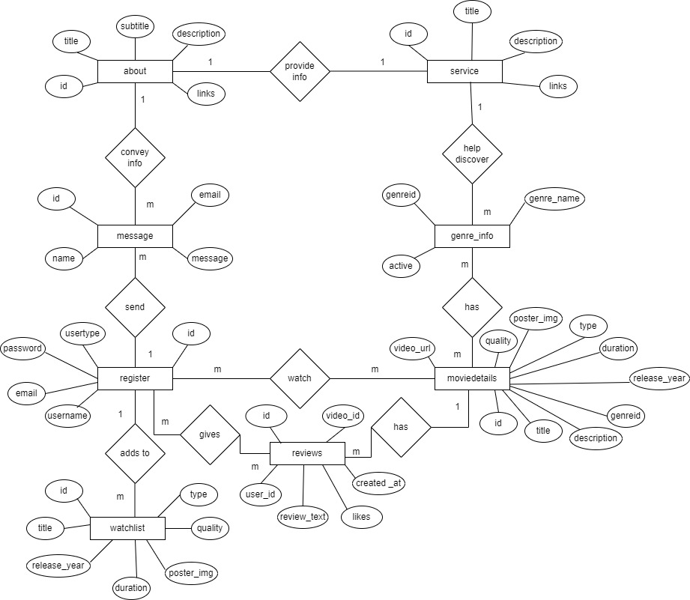
Figure 3: ER-Diagram of MovieMagic

Entities:

The ER diagram represents a movie database with the following entities:
- Register: Represents a user or an admin based on the user type.
- MovieDetails: Represents a movie with information like title, description, genre, etc.
- Message: Represents a message sent by users.
- Watchlist: Represents a list of movies a user wants to watch.
- Reviews: Represents user reviews of a movie.
- About: Represents information about the platform.
- Genre_info: Provides information about the genre.

3.1.4 Process Modeling

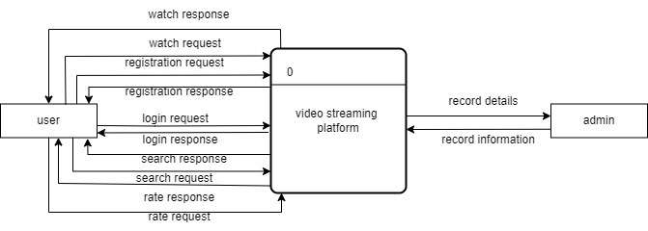
Figure 4: DFD level-0 of MovieMagic

The context diagram provides a top-level view of how the system interacts with its environment and the data it processes. It does not go into the details of internal processes; instead, it focuses on the high-level relationships between the system and external entities. It interacts with the user as:
- From Users to System: login credentials, registration information, search queries, streaming requests.

From System to Users: streamed content, user account information.

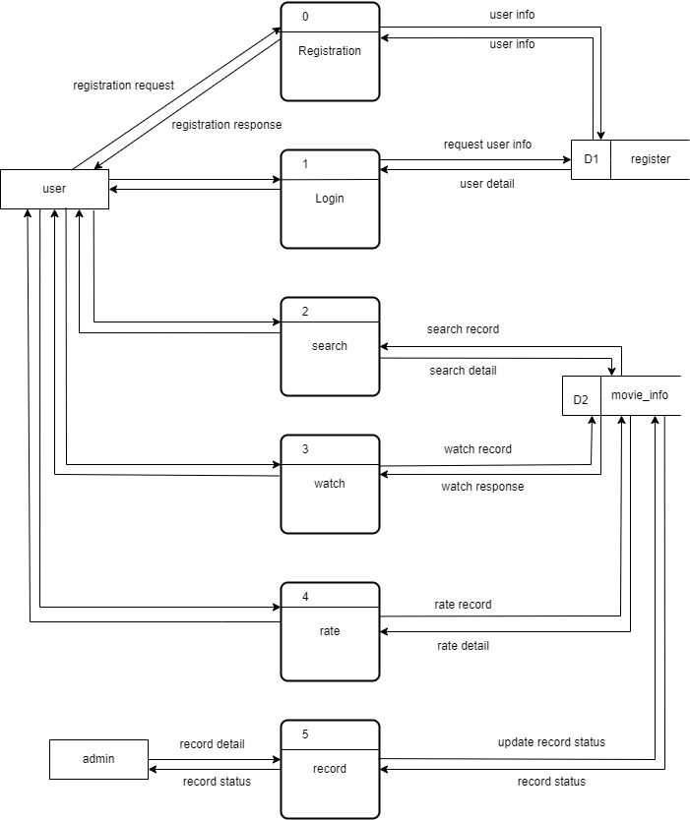
Figure 5: DFD level 1 of MovieMagic

This Level 1 DFD provides an overview of how different processes interact with data stores and external entities. It outlines the flow of data within the system and the basic functionality of the various processes.
- Process: User Management
- Register User: Collects user information (username, password, email) and saves it in the user Database.
- Login User: Authenticates user credentials from the User Database and grants access.
- Process: Streaming Service
- Stream Movie: Streams requested movies to users.
- Data Stores
- User Database: Stores user registration and login data.
- Movie Database: Stores movie information including titles, descriptions, genres, and streaming links.

External Entities:
- Users:
- Provide registration information, login credentials, and movie requests.
- Receive streamed movies, movie information.
- Admin:
- Provides new movie data, updated movie data, and delete requests.
- Receives success or error messages for movie creation, updates, and deletions.

3.1.5 Flow Chart for Admin:
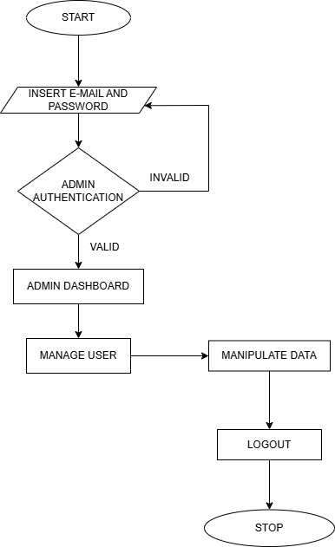
Figure 6: Flow-chart of Admin
In the above figure 3.6, flowchart diagram of admin where admin can manage and handles the User Information and Movie/TV-Shows details.

3.1.5 Flow Chart for User:
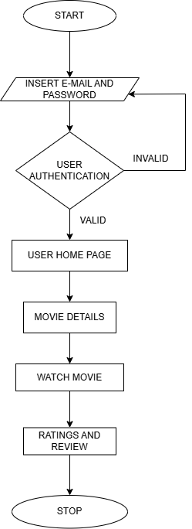

Figure 7: Flowchart of User
In the above figure 3.7, The user flowchart diagram above allows users to watch movies and TV series based on their preferences, complete with descriptions, trailers, and other details about the actors, directors, and writers.With a personalized recommendation system, one can also view the ratings and reviews of the films left by other users.

Chapter 4: System Design

4.1 Design
The movie streaming platform has a user-friendly style that makes it simple to navigate on desktop. Its easy-to-use movie and TV program classification improves user accessibility. Personalized suggestions and convenient access to stored material are made possible by user profiles. A secure and seamless user experience is ensured by consistent branding and strong security measures that safeguard user data and transactions.

4.1.1 Architectural Design

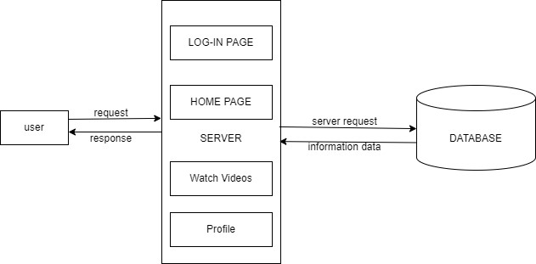
Figure 8: Architectural Design of MovieMagic

An architectural diagram for movie streaming website provides an overview of the system's structure, including its major components, their interactions, and how data flows between them. This kind of diagram helps you understand how the different parts of the system work together to achieve the desired functionality.

Key components:
- Client Interfaces:
- Web Interface:

A frontend application that allows users to interact with the system, such as browsing movies, registering, logging in, and streaming movies.
- Server Components:
- Web Server:

Handles incoming HTTP requests from clients and serves static content.
- Application Server:

Hosts the backend logic of the application, handling requests from clients and interacting with databases and other external services.
- Data Stores:
- User Database:

Stores user data, such as registration details, login credentials, and profile information.
- Movie Database:

Stores movie data, such as titles, descriptions, genres, and streaming URLs.
- Interactions and Data Flow:
- User Interactions:

Users interact with the system through the web interface. They can browse movies, register, log in, and stream content.
- Server Interactions:

The web server and application server handle requests and responses from clients, routing requests to the appropriate backend services.
- Database Interactions:

The application server interacts with the user and movie databases to create, read, update, and delete data as required by user and admin actions.

4.1.2 Interface design

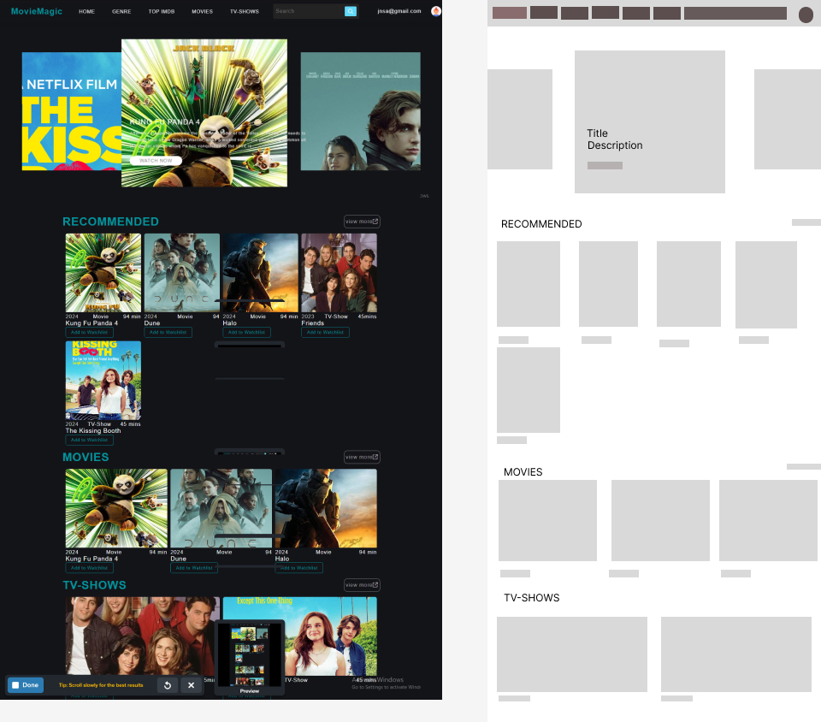
Figure 9:Interface Design

Header
- Logo and Branding: The logo "MovieMagic" is placed on the top-left corner.
- Navigation Menu: Key sections like "Home," "Genre," "Top IMDB," "Movies," and "TV Shows" are prominently displayed, providing easy navigation.
- Search Bar: A search bar is located centrally, enabling users to quickly find specific content.
- User Profile: The top-right corner features the user’s email, indicating the logged-in status.

Main Content Area
- Featured Section: The top portion showcases a large banner area with featured content. It highlights the latest and most popular movies or TV shows to catch the user's attention. For instance, "The Kissing Booth" and "Kung Fu Panda 4" are prominently displayed.
- Recommended Section: Below the featured content, a "Recommended" section displays suggested movies and TV shows tailored to the user’s preferences. Each item includes a thumbnail, title, duration, type (movie or TV show), and options to add to the watchlist.
- Movies Section: This section lists movies, allowing users to scroll through the latest or popular movies available on the platform. Thumbnails are used to attractively display each movie with its title and duration.
- TV Shows Section: Similar to the movies section, this area features TV shows. It includes thumbnails, titles, and episode durations to help users quickly identify and select content.

Design Elements
- Consistent Layout: The design uses a grid layout for organized and consistent presentation. Each section is clearly demarcated, making it easy for users to browse content.
- Dark Theme: A dark color scheme is used, which is common for streaming platforms to enhance visual appeal and reduce eye strain during prolonged viewing.
- Interactive Elements: Buttons like "Add to Watchlist" and "View More" offer interactivity, encouraging user engagement with the content.

Wireframe
- The wireframe on the right side provides a structural overview, showing the planned layout without design elements. It outlines where each section and content type will be placed, aiding in the development process by ensuring all elements are accounted for before the final design.

4.1.5 Database design schema

Table 1:about
id | int(20)AUTO_INCREMENT PRIMARY KEY
title | varchar(50)
subtitle | varchar(50)
description | Longtext
links | varchar(100)

Table 2:genre_info
Genreid | int(11)AUTO_INCREMENT PRIMARY KEY
genre_name | varchar(50)
Active | int(4)

Table 3:message
id | int(11)AUTO_INCREMENT PRIMARY KEY
name | varchar(50)
email | varchar(150)
message | Longtext

Table 4:moviedetails
id | int(11) AUTO_INCREMENT PRIMARY KEY
title | varchar(191)
description | Longtext
genreid | int(11)
release_year | int(11)
duration | varchar(30)
type | varchar(30)
poster_img | varchar(191)
quality | Mediumtext
video_url | varchar(255)

Table 5:register
id | int(11)AUTO_INCREMENT PRIMARY KEY
username | varchar(50)
email | varchar(150)
password | varchar(50)
usertype | varchar(20)

Table 6:reviews
id | int(11) AUTO_INCREMENT PRIMARY KEY
video_id | int(11)
user_id | int(11)
review_text | Text
likes | int(11)
created_at | Timestamp

Table 7:service
id | int(20) AUTO_INCREMENT PRIMARY KEY
title | varchar(50)
description | Longtext
links | varchar(100)

Table 8:watchlist
id | int(11) AUTO_INCREMENT PRIMARY KEY
title | varchar(50)
release_year | int(11)
duration | varchar(30)
poster_img | varchar(191)
quality | Mediumtext
type | varchar(5)

Here's a brief explanation of some of the terms in the context:
subtitle, title, description, links, about, id, name, message, send, usertype, register, password, username,email, genreid, genre_name, genre_info, active, has, watch, moviedetails, URL, quality, poster_img, release_year, type, duration
These terms are common in movie or TV show databases and refer to various attributes associated with a movie or TV show.
- subtitle: Subtitles available for the movie or TV show.
- title: The name of the movie or TV show.
- description: A brief summary of the movie or TV show's plot.
- links: Any external links related to the movie or TV show, such as its official website or social media pages.
- about: Additional information about the movie or TV show.
- id: A unique identifier for the movie or TV show.
- name: The name of the user or entity associated with the movie or TV show.
- message: A message related to the movie or TV show.
- send: The action of sending a message or request related to the movie or TV show.
- usertype: The type of user account, such as a free or premium user.
- register: The action of registering for a user account.
- password: The secret code used to authenticate a user account.
- username: A unique name used to identify a user account.
- email: The user's email address.
- genreid: A unique identifier for the genre of the movie or TV show.
- genre_name: The name of the genre of the movie or TV show.
- genre_info: Additional information about the genre of the movie or TV show.
- active: A flag indicating whether the movie or TV show is currently available.
- has: A flag indicating whether the user has access to the movie or TV show.
- watch: The action of watching the movie or TV show.
- moviedetails: Detailed information about the movie or TV show.
- video_url: The web address of the movie or TV show's page.
- quality: The video quality of the movie or TV show.
- poster_img: The image used to represent the movie or TV show.
- release_year: The year the movie or TV show was released.
- type: The type of media, such as a movie or TV show.
- duration: The length of the movie or TV show.

Chapter 5: Implementation and Testing

5.1 Implementation
The waterfall model is applied to develop a movie streaming platform through a systematic, sequential approach. It begins with gathering comprehensive requirements from stakeholders and users, detailing functionalities like content categorization, playback quality, and user interface design. With these requirements in hand, the platform's architecture is meticulously designed, encompassing frontend layout, backend infrastructure for data storage, and scalability considerations for future growth. Development follows, where software engineers write code and integrate necessary components, ensuring each phase is completed before moving to the next. Rigorous testing is then conducted to verify functionality and performance, ensuring seamless user experience and reliability in streaming services. Once tested and approved, the platform is deployed, and ongoing maintenance ensures it meets user expectations while adhering to security standards and evolving industry trends.

5.1.1 Tools Used

For our movie streaming platform project, a combination of essential tools and technologies is employed across various development phases:

Frontend:
- HTML: Utilized to structure and define the content and layout of web pages, including movie listings, user profiles, and streaming interfaces.
- CSS: Used for styling and enhancing the visual presentation of the platform, ensuring a cohesive and user-friendly design.
- JavaScript (JS): Implements interactive features and dynamic content updates, enhancing user engagement and functionality across different devices.

Backend:
- PHP: Powers server-side operations and dynamic content generation, handling user authentication, session management, and database interactions.

Database:
- MySQL: Serves as the database management system to store and manage movie metadata, user data, and transactional information efficiently.

Development Environment:
- Visual Studio Code (VSCode): Chosen as the primary integrated development environment (IDE) for coding frontend and backend components. VSCode provides robust editing capabilities, debugging tools, and extensions for seamless workflow management and collaboration.

By leveraging these tools effectively, MovieMagic aims to deliver a responsive, secure, and feature-rich experience for users, ensuring efficient data management and seamless interaction across different devices and platforms.

5.1.2 Implementation details of modules
The different modules provided are:

Module 1: Browse Movies
It provides an interface for users to browse available movies across various genres and categories.
Features:
- Users can view movie details, including titles, descriptions, genres, and ratings.
- Allows users to sort and filter movies based on different criteria (e.g., release date, popularity, genre).
- Displays thumbnails or posters for each movie to aid in visual browsing.
Module 2: Stream Movies
It enables users to stream selected movies directly on their devices.
Features:
- Users can select a movie to watch from the list of available options.
- Provides playback controls such as play, pause, and volume adjustments.
Module 3: Admin Manage Movies
It allows the admin to manage the movie database, including adding, updating, and deleting movies.
Features:
- Admin can add new movies, including their metadata (titles, descriptions, genres, release dates, etc.).
- Admin can update existing movies, such as modifying descriptions or genres.
- Admin can delete movies from the database as needed.
Add:
<table class="table table-bordered" id="dataTable" with="100%" cellspacing="0">
<thead>
<tr>
<th>ID</th>
<th>TITLE</th>
<th>RELEASE YEAR</th>
<th>DURATION</th>
<th>IMAGE</th>
<th>EDIT</th>
<th>DELETE</th>
</tr>
</thead>
<tbody>
<?php
if(mysqli_num_rows($result)>0)
{
while($row=mysqli_fetch_assoc($result))
{
?>

<tr>
<td><?php echo $row['id']; ?></td>
<td><?php echo $row['title']; ?></td>
<td><?php echo $row['release_year']; ?></td>
<td><?php echo $row['duration']; ?></td>
<td><?php echo '<img src="upload/'.$row['poster_img'].'" width="100px;" height="100px;" alt="Movie Poster">'?></td>
<td>
<form action="moviedetails.php" method="POST">
<input type="hidden" name="edit_id" value="<?php echo $row['id']; ?>">
<button type="submit" name="edit_btn" class="btn btn-success">EDIT</button>
</form>
</td>
<td>
<form action="code.php" method="POST">
<input type="hidden" name="delete_id" value="<?php echo $row['id']; ?>">
<button type="submit" name="movie_delete_btn" class="btn btn-danger">DELETE</button>
</form>
</td>
</tr>
<?php
}
}
else
{
echo "No Records Found!";
}
?>
</tbody>
</table>
Update:
div class="container-fluid">
<div class="card shadow mb-4">
<div class="card-header py-3">
<h6 class="m-0 font-weight-bold text-primary">Edit Movie Details</h6>
</div>
<div class="card-body">
<?php
if (!$connection) {
die("Database connection failed: " . mysqli_connect_error());
}

if (isset($_POST['edit_btn'])) {
$id = $_POST['edit_id'];
$query = "SELECT * FROM moviedetails WHERE id='$id'";
$result = mysqli_query($connection, $query);

if (!$result) {
die("Query failed: " . mysqli_error($connection));
}

// Check if any row is fetched
if (mysqli_num_rows($result) > 0) {
$row = mysqli_fetch_assoc($result);
$current_genre = $row['genreid'];
$current_image = $row['poster_img'];
?>
<form action="code.php" method="POST" enctype="multipart/form-data">
<input type="hidden" name="edit_id" value="<?php echo $row['id']; ?>">

<div class="form-group">
<label>Title</label>
<input type="text" name="m_title" class="form-control" placeholder="Enter Movie Title" value="<?php echo $row['title']; ?>">
</div>
<div class="form-group">
<label> Description</label>
<textarea name="description" class="form-control" required rows="3"><?= $row['description']; ?></textarea>
</div>
<div class="form-group">
<label>Genre</label>
<select name="gid" class="form-control">
<?php
$sql = "SELECT * FROM genre_info WHERE active='1'";
$res = mysqli_query($connection, $sql);
$count = mysqli_num_rows($res);
if($count>0)
{
while($col=mysqli_fetch_assoc($res))
{
$genre_title = $col['genre_name'];
$genreid = $col['genreid'];
?>

<option
<?php if($current_genre == $genreid) {echo "selected";} ?> value="<?php echo $genreid; ?>">
<?php echo $genre_title; ?>
</option>

<?php
}
}
else
{
echo "<option value='0'>Category Not Available</option>";
}

?>
</select>
</div>
<div class="form-group">
<label>Release Year</label>

<input type="text" name="m_year" class="form-control" placeholder="Enter Released Year" value="<?php echo $row['release_year']; ?>">
</div>
<div class="form-group">
<label>Duration</label>
<input type="text" name="m_duration" class="form-control" placeholder="Enter Duration" value="<?php echo $row['duration'] ?? ''; ?>">
</div>
<div class="form-group">
<label>Type</label>
<input type="text" name="m_type" class="form-control" placeholder="Enter Type" value="<?php echo $row['type'] ?? ''; ?>">
</div>
<div class="form-group">
<label> Current Poster Image</label><br>
<td>
<!-- Display image if available -->
<?php
if($current_image == "")
{
echo "<h6>Image not Available</h6>";
}
else
{
echo '<img src="upload/'.$row['poster_img'].'" width="100px;" height="100px;" alt="Movie Poster">';
}
?>
</td>
</div>
<div class="form-group">
<label> New Poster</label>
<input type="file" name="m_img" id="m_img" class="form-control" placeholder="Insert Image">
</div>
<div class="form-group">
<label>Quality</label>
<input type="text" name="m_quality" class="form-control" placeholder="Enter Duration" value="<?php echo $row['quality'] ?? ''; ?>">
</div>
<a href="movie_info.php" class="btn btn-danger">CANCEL</a>
<button type="submit" name="updatebtn" class="btn btn-primary">Update</button>
</form>
<?php
} else {
echo "No data found for ID: " . $id;
}
}
?>
</div>
</div>
</div>

Top of Form
Bottom of Form

Chapter 6: Conclusion and Future Improvements

6.1 Lesson learnt/outcome
The development of the MovieMagic project has been a significant journey marked by both challenges and achievements. The project successfully delivered an online movie streaming platform that prioritizes user experience. Throughout its development, valuable lessons were learned about the importance of meticulous planning, effective communication. Overcoming obstacles such as integrating databases and ensuring seamless playback demonstrated the team's resilience and problem-solving abilities. By adhering to rigorous testing and quality assurance protocols, MovieMagic ensured a robust and reliable platform for users to enjoy their favorite movies. The project's success underscores the importance of collaboration, technical expertise, and a user-centric approach in achieving project goals.

6.2 Conclusion

The MovieMagic project aimed to deliver an affordable, high-quality online movie streaming platform, successfully addressing the identified gaps in the digital entertainment landscape. By embracing a low-budget ethos, MovieMagic ensures accessibility for all users, without compromising on the quality of the cinematic experience. The platform's user-friendly interface, comprehensive movie catalog, and personalized watchlists redefine how users experience movies online.

Throughout the project, the waterfall methodology provided a structured approach, ensuring systematic progression through requirement gathering, system design, implementation, and testing. The detailed architectural design and interface wireframes guided the development process, resulting in a cohesive and reliable system. Rigorous testing ensured the platform's robustness, performance.

6.3 Future Recommendations

The movie streaming website can be improved further by incorporating advanced features such as personalized recommendations based on user viewing history and preferences. These personalized recommendations would enhance user engagement by tailoring content to individual tastes, thereby increasing the time users spend on the platform. Additionally, implementing a social sharing feature would enable users to share movies with friends and family, fostering a sense of community and potentially attracting new users through word-of-mouth. Integrating options for user-created playlists and favorites lists could provide more personalized content management, encouraging users to curate their own movie collections and return to the site regularly. Future iterations may also benefit from more sophisticated search and filtering options, which would help users find content more efficiently and improve their overall experience. Finally, improved quality control features could optimize the streaming experience, ensuring high-quality playback and reducing buffering or technical issues, which are critical for maintaining user satisfaction and engagement.

References

[1] A. &. A. P. Smith, "The impact of streaming technology on consumer behavior," 2020.

[2] M. Kumar, "Economic and technical challenges in the streaming market," 2021.

[3] L. W. Johnson, "Enhancing User Experience in streaming services," 2019.

[4] B. Boehm, "A spiral model of software development and enhancement," 1988.

[5] D. &. B. E. White, "Comparative analysis of streaming platforms: A market study," 2023.

